**PAAS ORCHESTRATOR**

1. **URL.**
2. **Registration page.**
3. **Login page.**
4. **Uploading a business process.**
5. **Creating a machine.**
6. **Creating a worker.**
7. **Executing a business process.**
8. **Managing Queues.**
9. **Creating Schedules.**
10. **Inviting User to organization.**
11. **Secret Vault.**
12. **URL: -**

To Register to “Orchestrator” you need to open the provided URL <http://35.244.21.24:3000>, After clicking on this page, you will be redirected to the Plans page of Orchestrator, below is a reference image for plans screen.

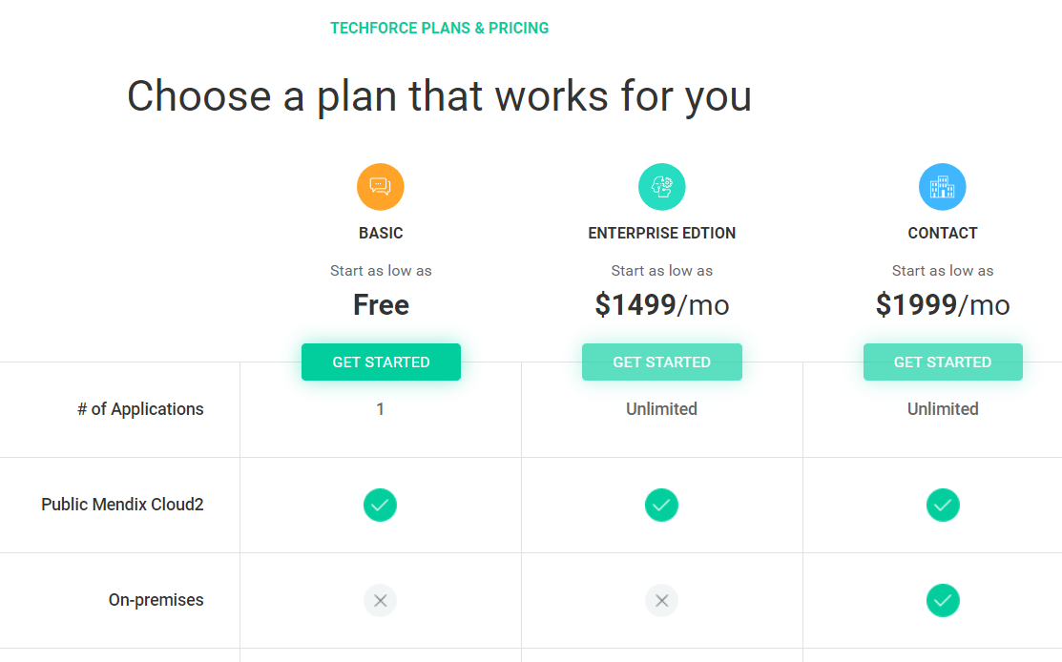

select your plan and click “Get Started” button, which will redirect you to registration page, if you already have an account you need to click this <http://orchestrator.development.techforce.ai> URL which will redirect you to LOGIN screen.

1. **Registration Page: -**

In the registration page you need to provide the details like, Company name if you have a logo of your company you can also upload logo, and your personal details like Shown in below image.  
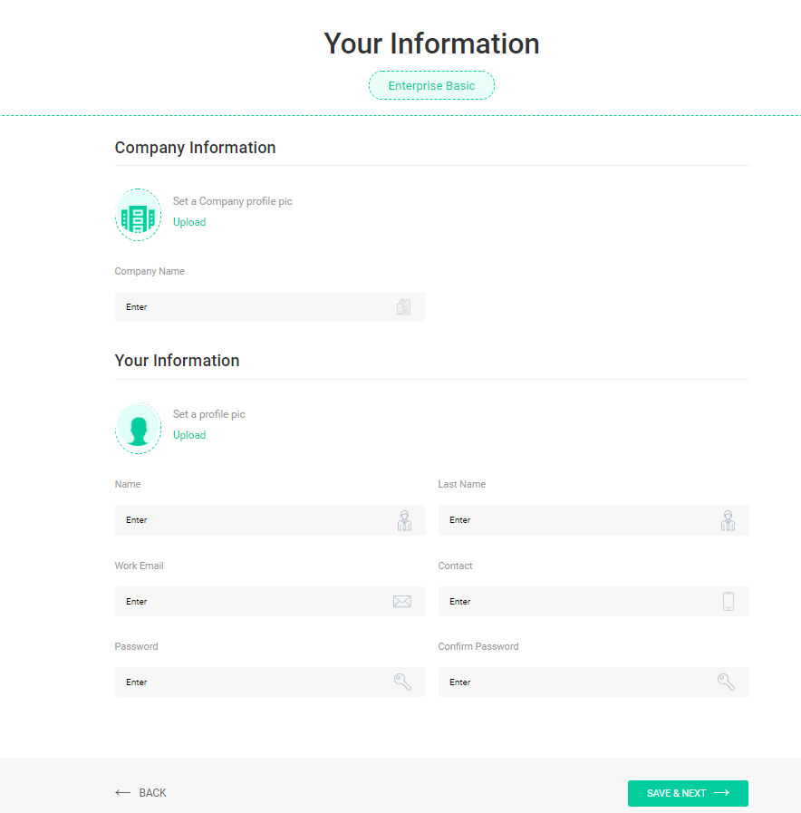

And click “Save & Next” button, which will send you a verification email, you need to verify your account, so that you can login to Orchestrator, below is the example image of verification Email.

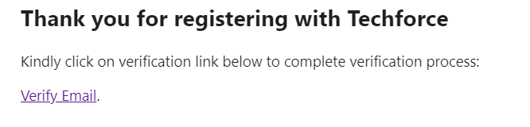

1. **Login page:-**

Here you need to enter the email id that you have registered with, and the password that you created at the time of registration process and click Login button which will redirect you to Home Page of Orchestrator.

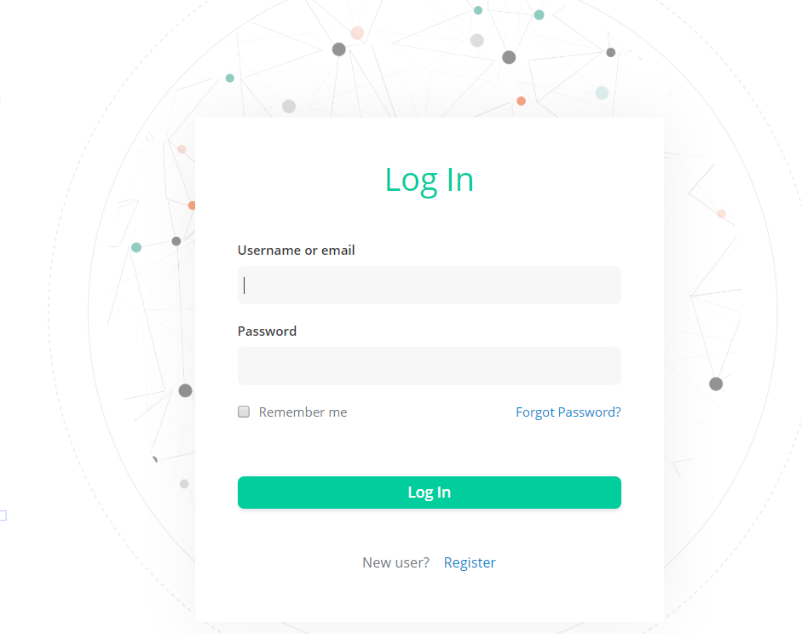

If you forgot your password, you can click on “Forgot password "link, which will redirect to the below screen you need to provide your registered email to get the reset password link.

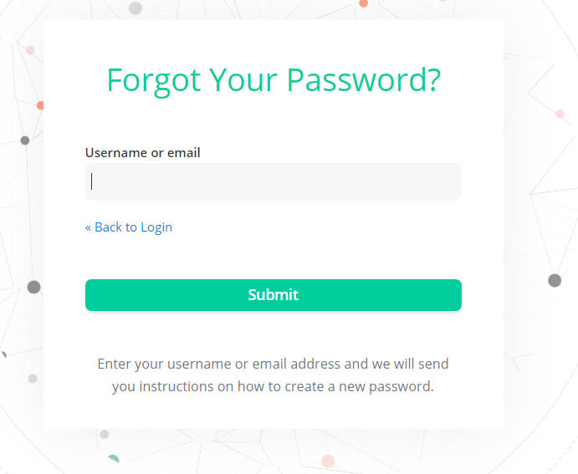

If you haven’t registered yet with Orchestrator you can click on “Register”, which will redirect you to Registration page.

After logging in you will be redirected to the screen shown below.

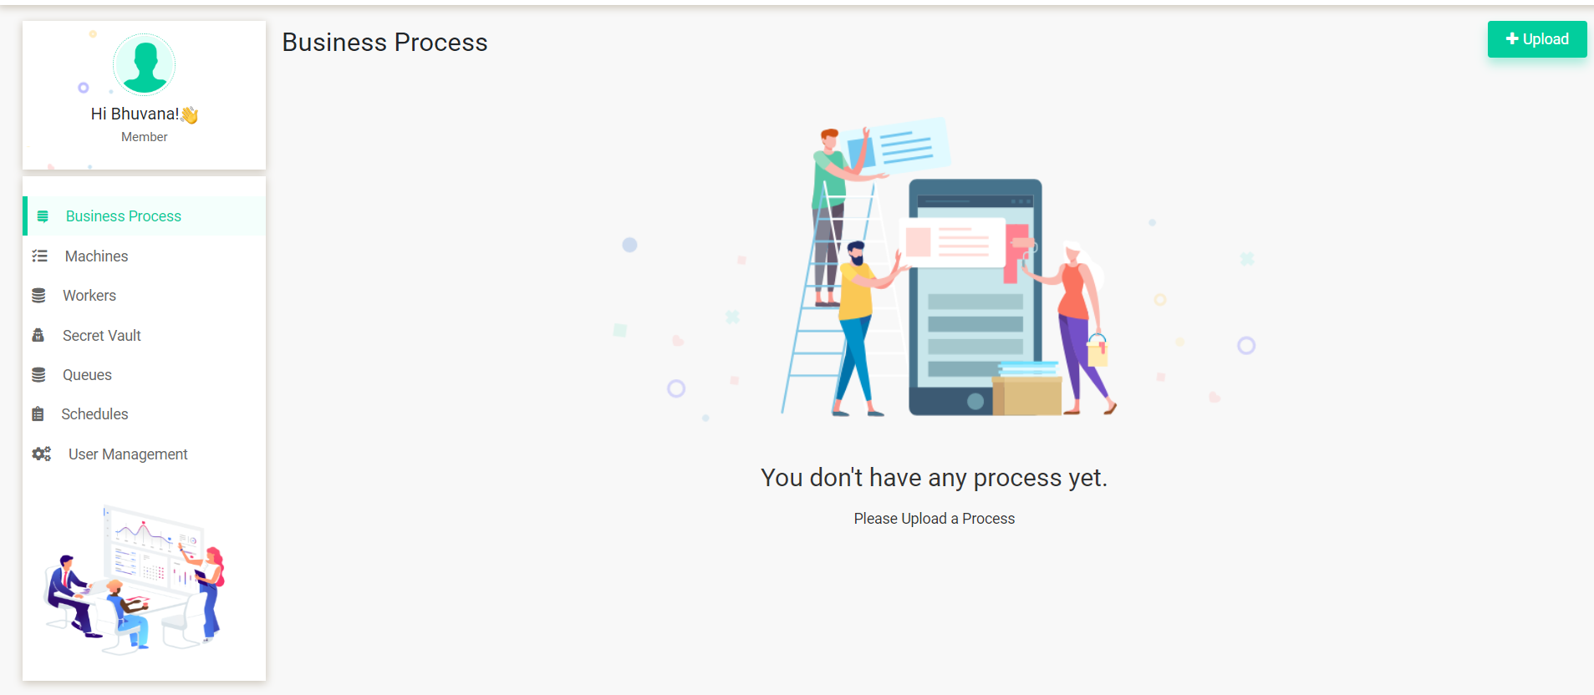

1. **Uploading a business process: -**

After successful login You will be redirected to the Business process screen, here you can upload the RPA script files as a Business process, after uploading you can execute the flow that you uploaded.

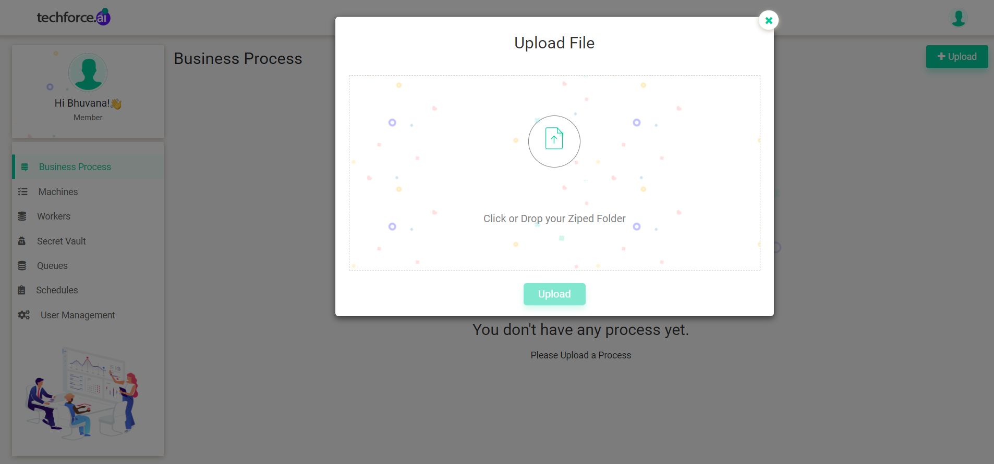

1. **Creating a machine: -**

You need to add/create machine in order to create a worker, so to create a machine you need to click on the “Machines” options from the list which is in the left side menu.

After navigating to Machines page, you need to click on Add button from the machines page in order to create a new machine. In the add machine pop-up you need to give Machine name and machine type.

In machine type we have two options those are

I. Reserved.

II. Dynamic.

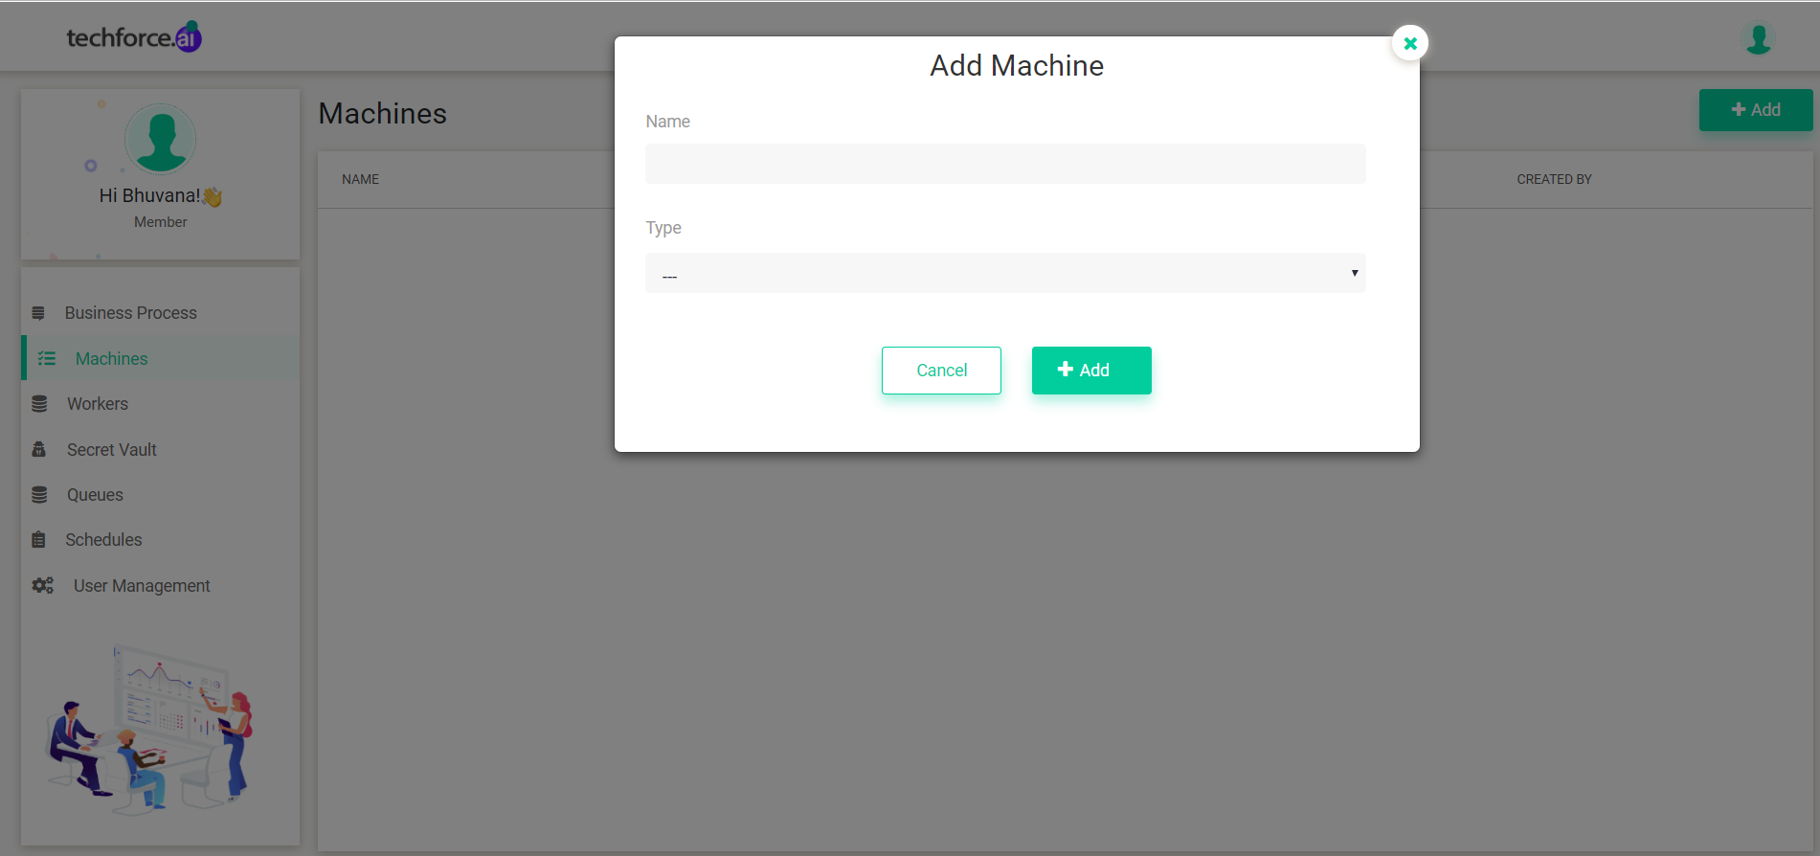

1. **Creating a worker: -**

The main functionality of a worker is to execute the flows/business processes that are uploaded under business process page. So, after adding the worker while executing the business process you need to select the worker that we created in worker screen. Below is the image for creating a worker.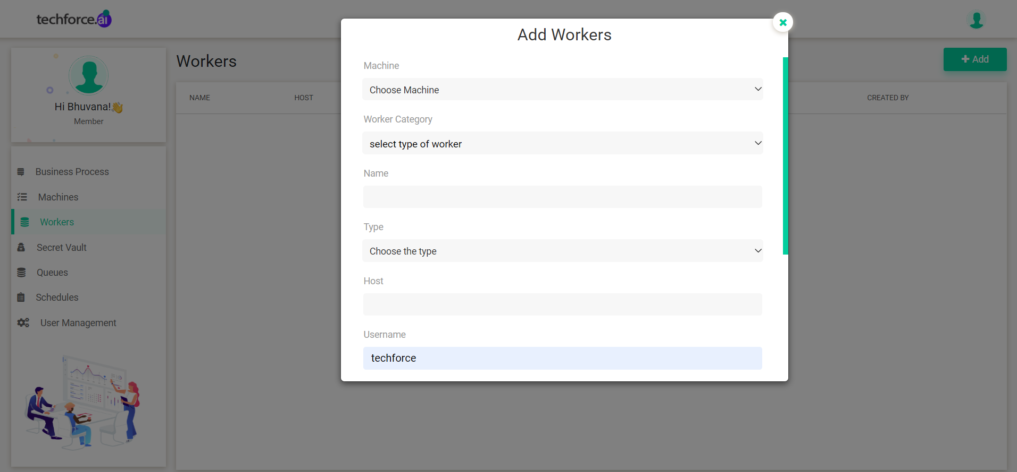

Here you need to select the machine for the worker, you need to select the “Category” of worker, need to give the “Name” for the worker, you need to give the “Host Name” I.e. IP Address of your machine, and if your machine has any user name and password then you need to provide those details too.

**Worker Categories**

There are two worker categories in our Orchestrator, those are,

* 1. **Reserved**

The Reserved category defines that, if you create a worker as “Reserved” then you can execute flows/business processes only to that machine.

* 1. **Dynamic**

If you create worker category type as “Dynamic” then Orchestrator will pick the worker dynamically which ever dynamic worker is free/idle.

**7. Executing a business process: -**

In business process page you can upload the RPA flow after uploading the flow you can execute the flow by clicking on the play button from the UI. After clicking on the play button, you can see the below image.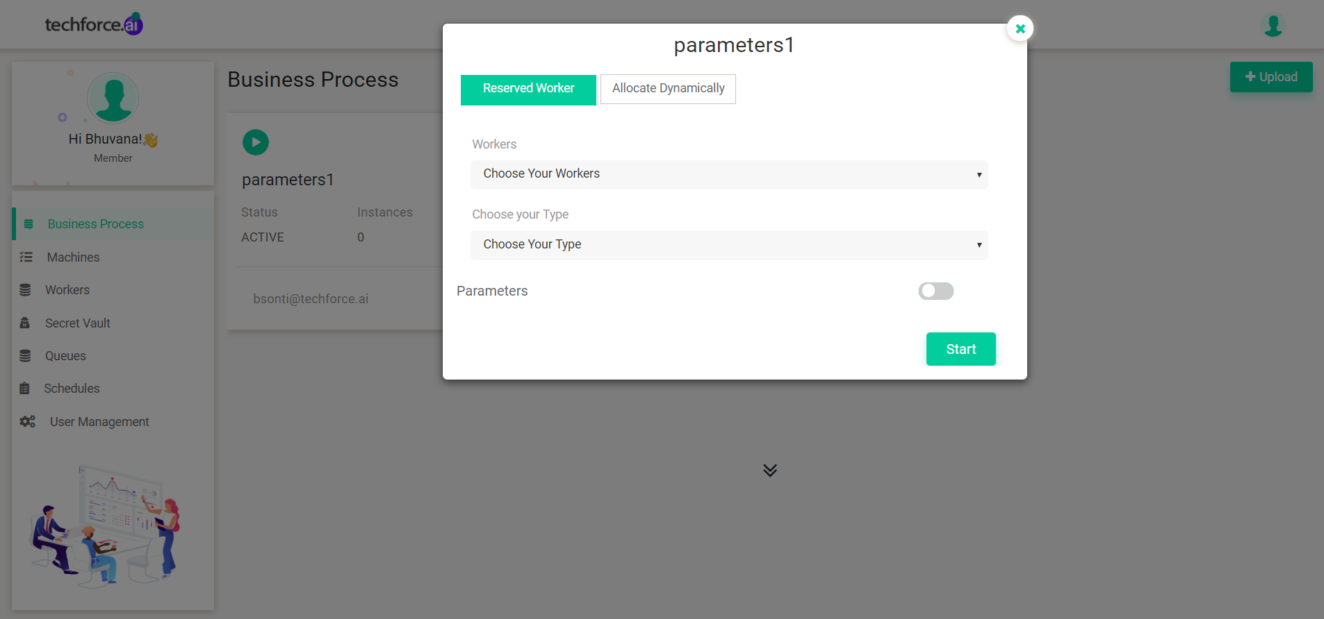

You need to select the Execution target Type like Reserved/Dynamic, if you select the execution type as reserved then you need to specify the Worker, but if you choose the Execution type as “Allocate dynamically” then you need not select the worker, Orchestrator will pick the worker which is free/idle.

**8. Managing Queues: -**

Queues is the functionality where you can see the status of currently executing bots/workers status and scheduled workers execution status.

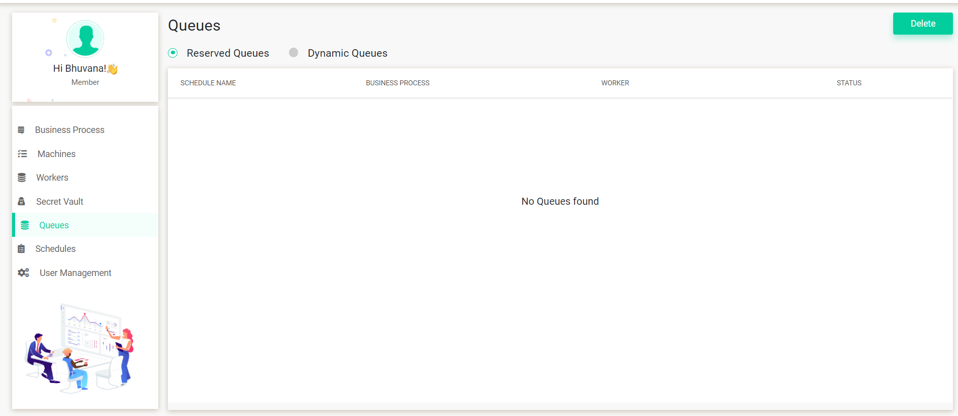

**9. Creating Schedules: -**

The main functionality of scheduling is, you can schedule/execute your RPA scripts whenever you want. After uploading a business process/RPA flow you can schedule those flows. So, to Schedule a flow first you need to create a “Schedule”.

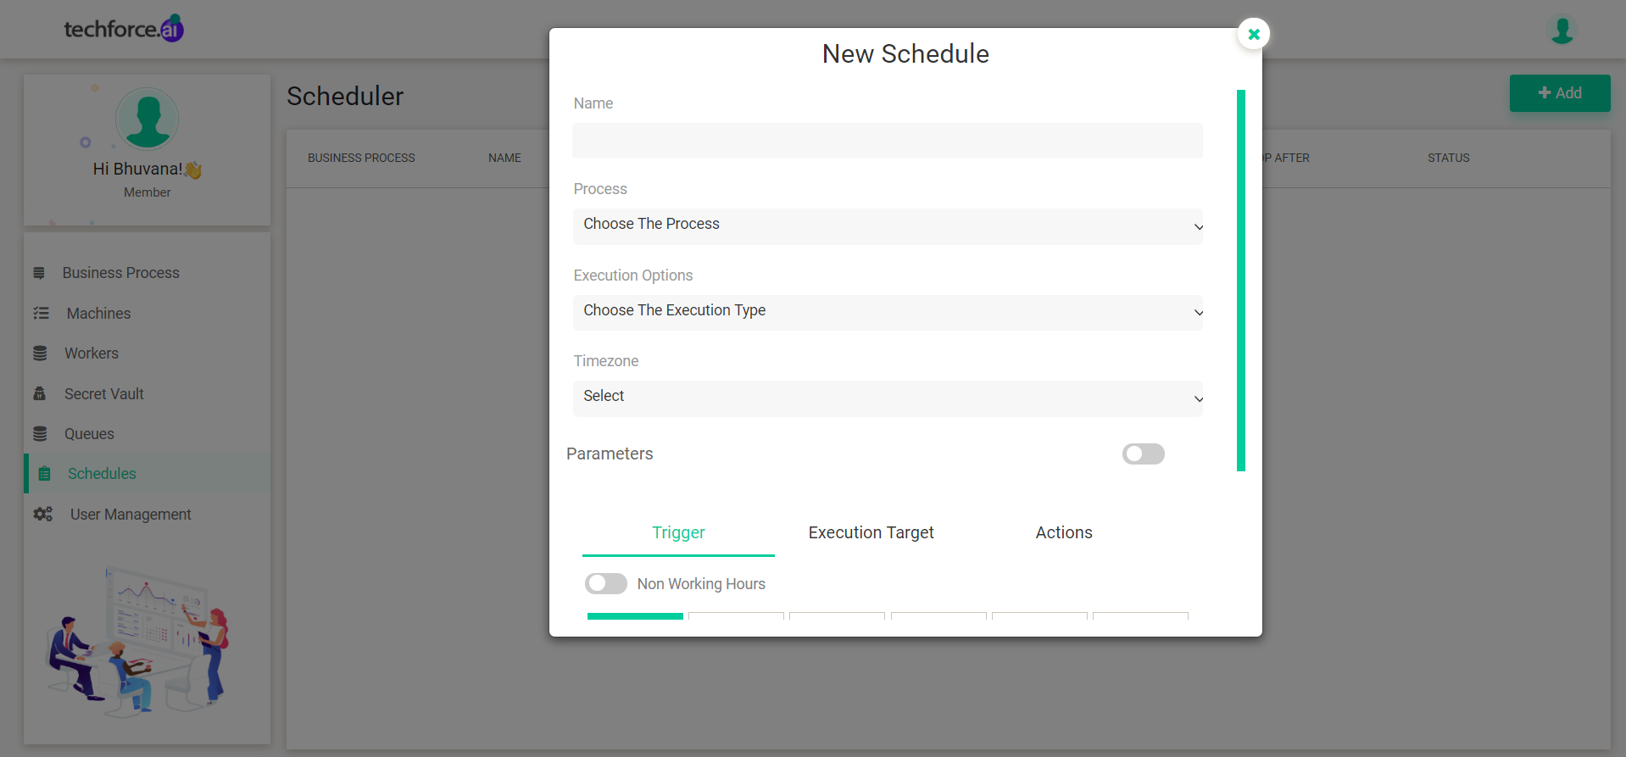

To create a “Schedule”, you need to navigate to “Schedules” page, after navigating to schedules page you need to click on “Add” button to start adding a new schedule, above is the sample screen of how to create a new schedule.

You need to name the schedule that you are creating, you need to choose the “Process” I.e. you need to select “Business process” that you want to schedule, and you need to select in which time zone you want to schedule the flow.

1. **Parameters**

The main functionality of parameters is to pass the values to the RPA flow/business process at runtime.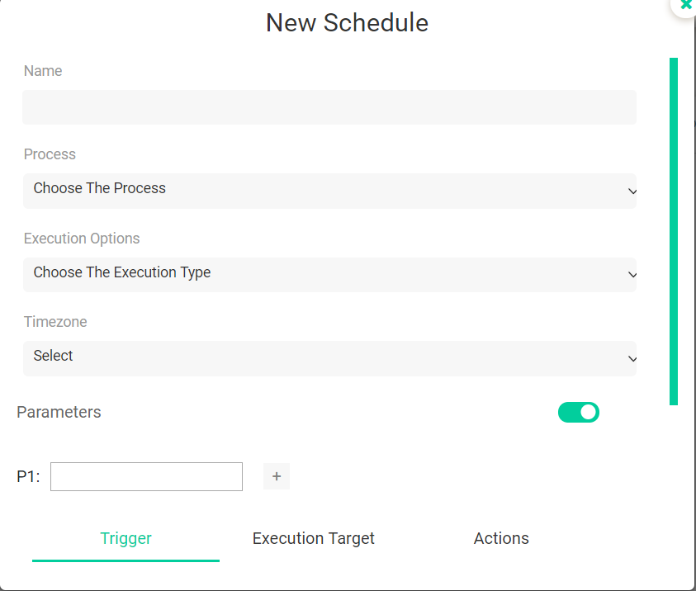

1. **Trigger**

Here you can specify at what time you want to schedule your flows/business processes.

**a. Minutes**

If you select the trigger type as minutes, then the business process will execute for every minute of time that you specified, for example you have scheduled a business process to execute for every 5 minutes then the flow will continuously execute for every 5 minutes until you stop/destroy that scheduled flow.

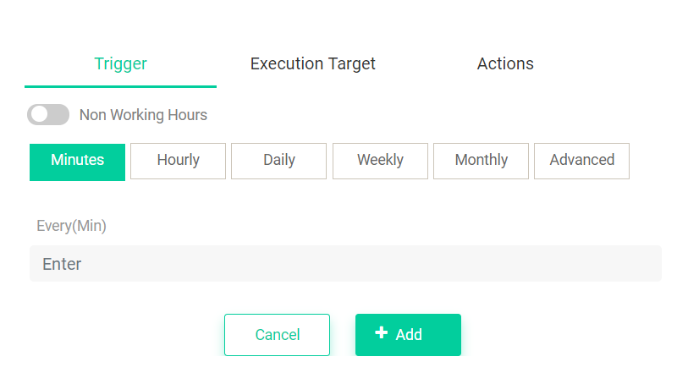

**b. Hourly**

If you select the trigger type as Hours, then the business process will execute for every Hour of time that you specified, for example you have scheduled a business process to execute for every 3 hours and 30 minutes then the flow will continuously execute for every 3 hours and 30 minutes until you stop/destroy that scheduled flow.

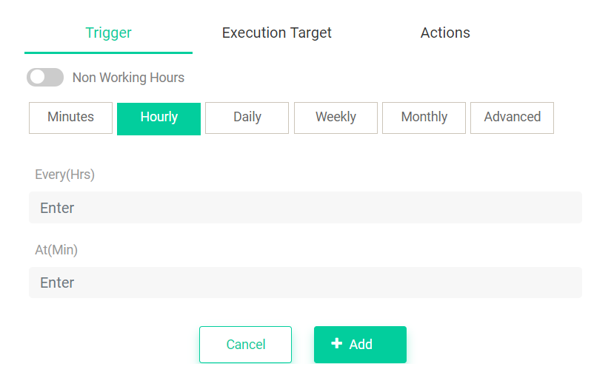

**c. Daily**

If you select the trigger type as Daily, then the business process will execute every Day at time that you specified, for example you have scheduled a business process to execute for every day at morning 05 AM and 30 minutes, then the flow will continuously execute every day at 05 AM and 30 minutes until you stop/destroy that scheduled flow.

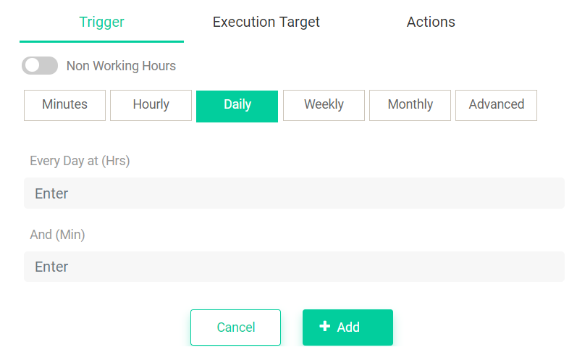

**d .Weekly**

If you select the trigger type as Weekly you need to select which week I.e. “Mon, Tue, and so on” then the business process will execute every Week at time that you specified, for example you have scheduled a business process to execute for every Monday at morning 05 AM and 30 minutes, then the flow will continuously execute every Monday at 05 AM and 30 minutes until you stop/destroy that scheduled flow.

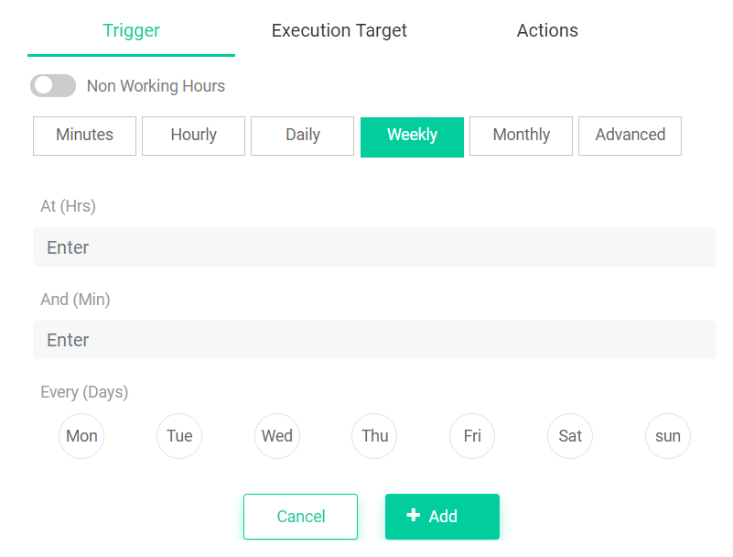

**e. Monthly:**

If you select the trigger type as Weekly you need to select which week I.e. “Jan, Feb, and so on” then the business process will execute every Month at time that you specified, for example you have scheduled a business process to execute on every Month at morning 05 AM and 30 minutes, then the flow will continuously execute every Month at 05 AM and 30 minutes until you stop/destroy that scheduled flow.

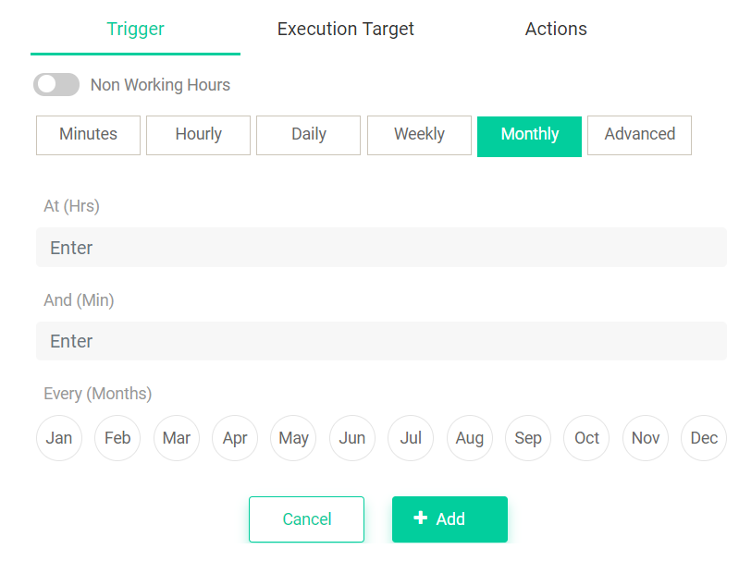

**f. Advanced:**

In Advanced option you can write a cron expression

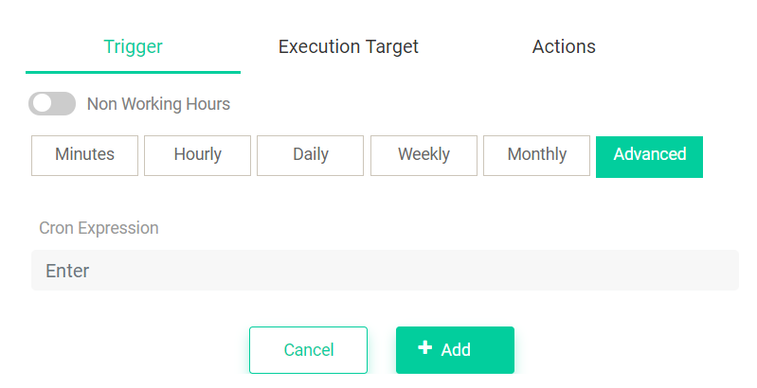 **III. Execution Target**

In execution target you can select the worker.

**A. Reserved Worker**

Reserved worker that means if you schedule a business process, the business process will execute only on that machine.

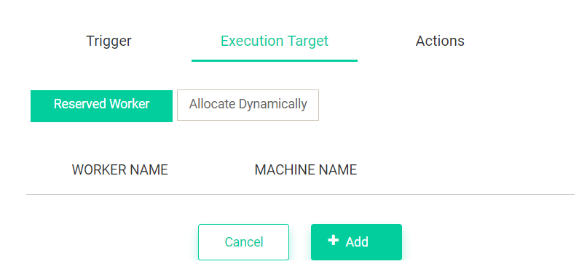

**B. Allocate Dynamically**

If you select the execution target as Dynamic then, Orchestrator will allocate the workers dynamically.

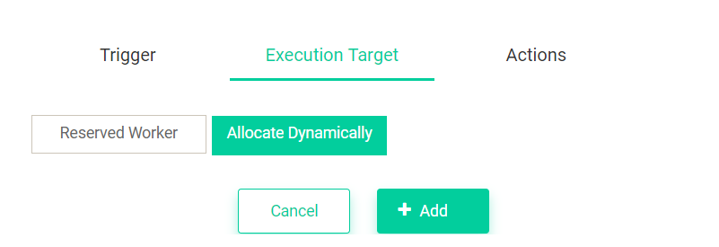

**IV.Actions**

In actions you can specify when to stop a scheduled bot.

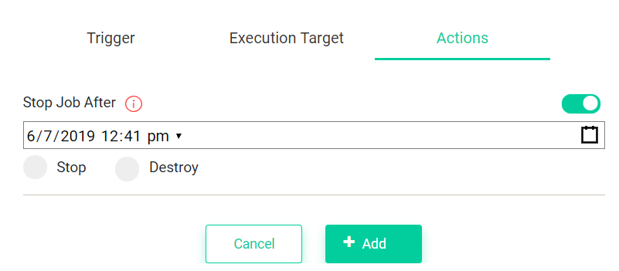

**10. Inviting User to organization: -**

To invite a user to your organization you need to navigate to “User management” page. You need to click on Invite button from user management page.

In the invite page screen, you need to enter the email of the person that you want to invite, you can select the Role of that member type as Admin or Member for that organization.

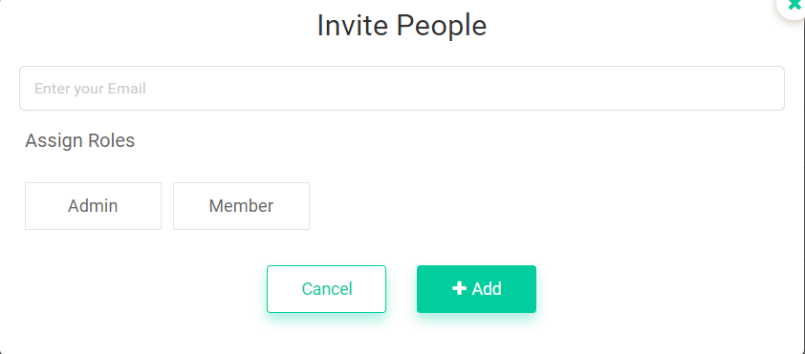

**11. Secret Vault: -**

The main functionality of Secret vault is you can create the values that you don't want to share or show to others. You can create a secret vault with different types like “Integer, Boolean, Text and Credentials”

**Single value**

Single value means if you create a Secret as single value then you can use that Secret to any worker you want.

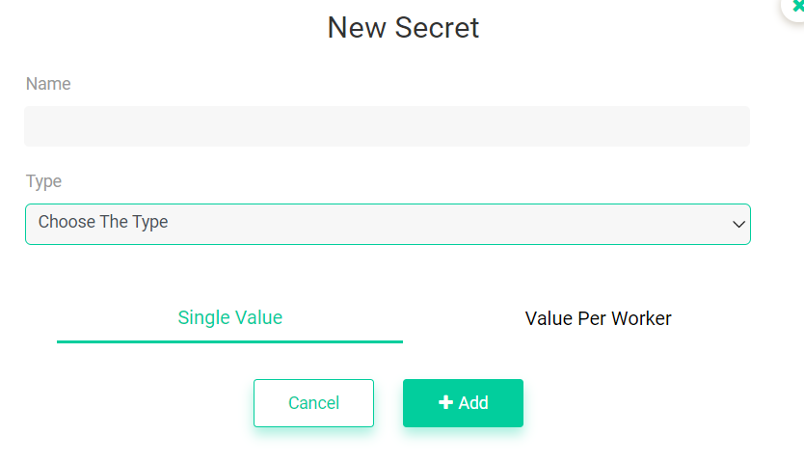

**Value per Worker**

Value per worker means you need to specify for which worker you want to assign the secret that you created.

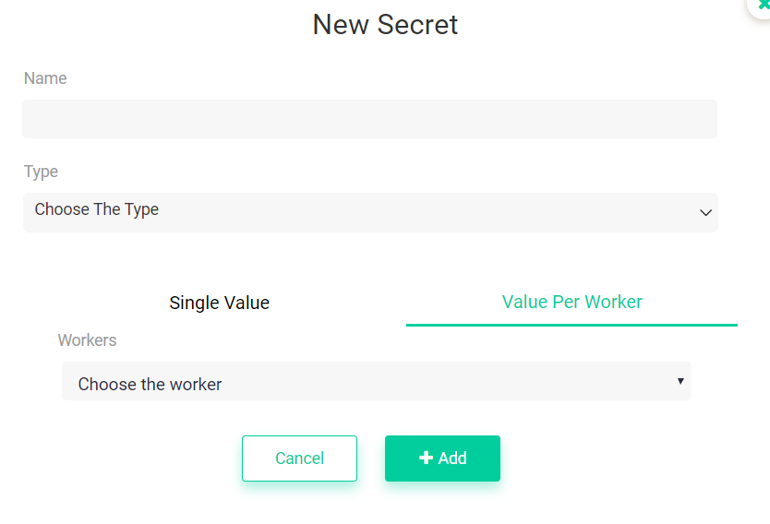

**Text:**

While creating a new secret you need to select the type of secret that you are creating, if you select the type as text then you can pass the value as text to the RPA flow.

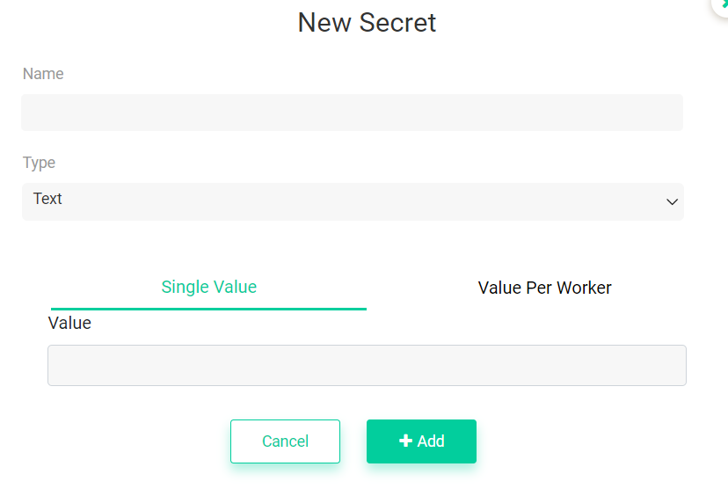

**Boolean:**

While creating a new secret you need to select the type of secret that you are creating, if you select the type as Boolean then you can pass the value as text to the RPA flow.

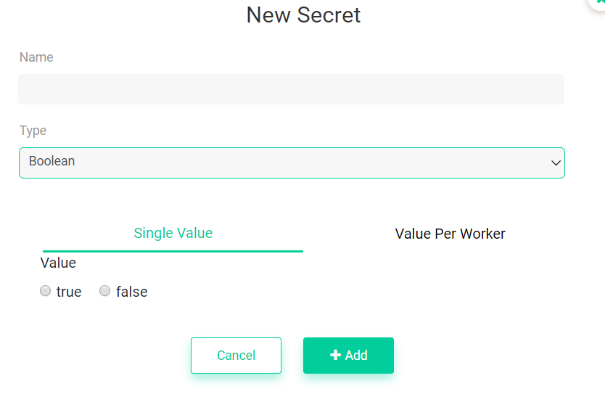

**Integer:**

While creating a new secret you need to select the type of secret that you are creating, if you select the type as Integer then you can pass the value as text to the RPA flow.

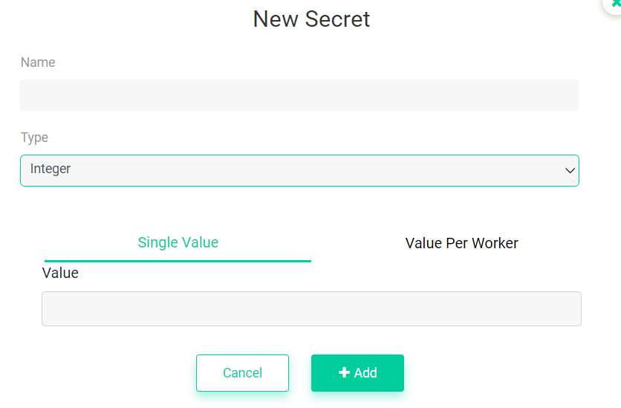

**Credentials:**

While creating a new secret you need to select the type of secret that you are creating, if you select the type as Credentials then you can pass the value as text to the RPA flow which will never shown to any other user.

